Early Fish Degradation Trigger Alert System
A White Paper
Author: Sowmya Maddala Date: August 2025

Contents:
- Executive Summary
- Background & Motivation
- Data & Assumptions
- Methodology
  - Data Acquisition
  - Rolling Statistical Features
  - Initial Change Point Detection
  - Multi-Statistic Consensus Filtering (Per Sensor)
  - Multi-Sensor Fusion
  - Label Engineering
  - Machine Learning Models
  - Model Based Confirmation Layer
- Micro Example (Intuition)
- Visualization & Reporting
  - Methodology Workflow
  - ML models - Seer
  - ML models - Tuna
- Insights & Key Learnings
- Results
- Findings
- Business & Real-World Impact
- Limitations & Assumptions
- Future Improvements
- Conclusion
- Appendix A: Glossary
- Appendix B: Practical Settings

Executive Summary
Fish spoilage is a gradual yet critical process that significantly impacts food quality, safety, and economic value. Ensuring the freshness and quality of fish during storage and transportation is a critical challenge in the seafood industry. Traditional quality assessment methods rely on manual inspection or laboratory analysis, which are time-consuming, subjective, costly, and unsuitable for real-time monitoring.
This white paper presents the development of an Early Fish Degradation Trigger Alert System of Seer & Tuna fish species, which uses multisensor time-series data (e.g., hydrogen sulfide [H₂S], ammonia [NH₃], temperature, etc.), rolling statistical features and machine learning models to provide early, reliable, and automated alerts for fish degradation. The system is designed for real-time monitoring, enabling businesses across the seafood supply chain to make proactive, data-driven decisions that reduce spoilage, cost, and improve consumer safety.

Background & Motivation
- Problem: Fish is highly perishable, and spoilage can occur rapidly under improper storage. Even small delays in detection can lead to significant financial loss and consumer health risks. Early detection of spoilage indicators can help reduce waste, optimize storage conditions, and ensure food safety.

- Traditional Limitations: Manual inspections are inconsistent, subjective, and unable to capture early microscopic chemical/biological changes.

- Goal: Develop an automated, sensor-driven system that detects spoilage signals at their earliest onset by fusing multiple data streams into a single early warning trigger alert that is biologically meaningful, data-driven, and practical for operations.

Data & Assumptions
To ensure practical relevance, the dataset was collected under controlled conditions. Sensor readings were recorded continuously from the point when each fish sample was fresh until it was identified as spoilt. This provided a natural progression of freshness loss over time.

Methodology

Data Acquisition
- The dataset consists of two fish species: Seer (229 data points) and Tuna (195 data points). Data collection was carried out in September 2021. Each sample was monitored using gas sensors(eg., H₂S, NH₃, CO₂, O₂, VOC) and temperature sensors, with readings taken at regular intervals(e.g., every 5 minutes) until spoilage. This structure allowed us to capture the entire degradation process in a time-series manner, essential for developing early warning alerts.

- Gaps handled with a specialized imputation algorithm designed for online use (deduplicates timestamps, supports multiple interpolation methods, and—when enough history exists—can switch to dynamic LSTM; otherwise uses robust rolling IQR/median logic).

Rolling Statistical Features
For each sensor, compute with a 1-hour sliding window:
- Mean and Median (central tendency)
𝑧(𝑡) = 𝑥(𝑡) − µ1ℎ(𝑡)/σ1ℎ(𝑡)
- Z-Score:
- Rate of Change (ROC): (Δ chosen within the 1-hour
^{window)} 𝑅𝑂𝐶(𝑡) = 𝑥(𝑡) − 𝑥(𝑡 − Δ)
𝑟𝑅𝑂𝐶(𝑡) = 𝑥(𝑡) − 𝑥(𝑡 − Δ)∣𝑥(𝑡 − Δ)∣ + ϵ
- Relative ROC:
- Rolling quantiles: Q1, Q2 (median), Q3, and IQR = Q3 − Q1 for dynamic thresholds.
Intuition: Rolling statistics capture both gradual drift (median/mean) and sharp transitions (ROC/rROC/z-score) while adapting to local context.

Initial Change Point (CP) Detection
● Rule: Mark a candidate CP when a chosen rolling statistic (e.g., rolling mean, z-score, ROC, rROC) stays above its own rolling median (Q2) for ≥ 30 consecutive minutes.

Multi-Statistic Consensus Filtering (Per-Sensor)
- Retain a candidate CP only if at least 2 statistics (e.g., ROC and rROC) agree for the same sensor.

- Benefit: Reduces noise-driven spikes and false positives.

Multi-Sensor Fusion
- Elevate a CP to a final alert only when ≥ 2 different sensors detect a CP at the same timestamp.

- Apply a 1-hour minimum separation between finalized CPs to avoid redundant detections. Apply the 1-hour separation only after a CP is finalized (i.e., after multi-sensor agreement). This prevents suppressing valid detections that may occur shortly after a single-statistic, non-finalized candidate.

- Empirical note: ROC and relative ROC emerged as the most influential contributors to early CP detection.

Label Engineering
Because real spoilage labels were unavailable, we created synthetic labels that reflect expected biology and sensor behavior:
- Spoilage Index (Regression; 0–1)
  - Linear ramp via np.linspace(0,1,N)

  - Sigmoid for slow-then-fast progression

  - Exponential to mirror gases like H₂S/NH₃ that accelerate as spoilage progresses

  - Purpose: Train models to predict a continuous spoilage score from sensors at any time—independent of absolute elapsed time.

- Spoilage Levels (Classification; {0=Fresh, 1=Medium, 2=Spoiled})
  - Divide each experiment’s timeline into three equal segments → synthetic stage labels.

  - Purpose: Train models for a simple, operationally friendly freshness stage.

- Time-to-Spoil (Regression)
  - Label = (end_time – current_time) for each point.

  - Purpose: Estimate remaining shelf life on the fly.

Machine Learning Models
- Regression: Linear Regression, Random Forest, Gradient Boosting — trained to predict spoilage index and time-to-spoil from sensor inputs.
- Classification: Logistic Regression, Random Forest, SVM — trained to predict spoilage level (0/1/2).

Model-Based Confirmation Layer
After the multi-sensor CP is identified statistically (Steps 4.3–4.5), we apply model-based gating using predictions at the CP timestamp:
- Linear spoilage index ≥ 0.3

- Sigmoid spoilage index ≥ 0.3

- Exponential spoilage index ≥ 0.1

- Predicted spoilage level ≥ 1 (on 0–2 scale)

Only CPs meeting both the statistical criteria and these model thresholds are retained as critical alerts. This removes “early but non-critical” fluctuations and focuses on meaningful events.

Micro-Example (Intuition)
- For H₂S, suppose the rolling z-score exceeds 1.0 at 10:00 and stays > 1.0 until 10:30.

- Simultaneously, relative ROC >> 5%(1-hour rolling median of rolling relative ROC) over next 30 minutes starting from 10:00 to 10:30.

- Per-sensor consensus: (z-score, rROC) → candidate CP at 10:00–10:30 window.

- Multi-sensor fusion: NH₃ shows the same pattern in that interval with (median, mean) from 10:00 to 10:30 → final CP at 10:00, triggered at 10:30.

- Model layer: Predicted exponential spoilage index = 0.42, sigmoid = 0.38, linear = 0.35; spoilage level = 1 → alert retained.

Visualization & Reporting
Methodology Workflow
1a) Temperature Initial Change Point Detection
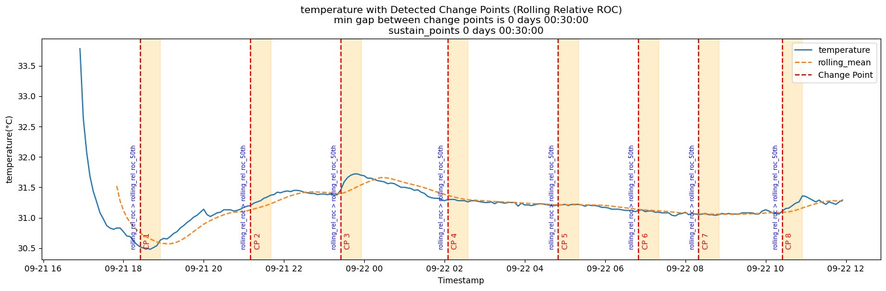
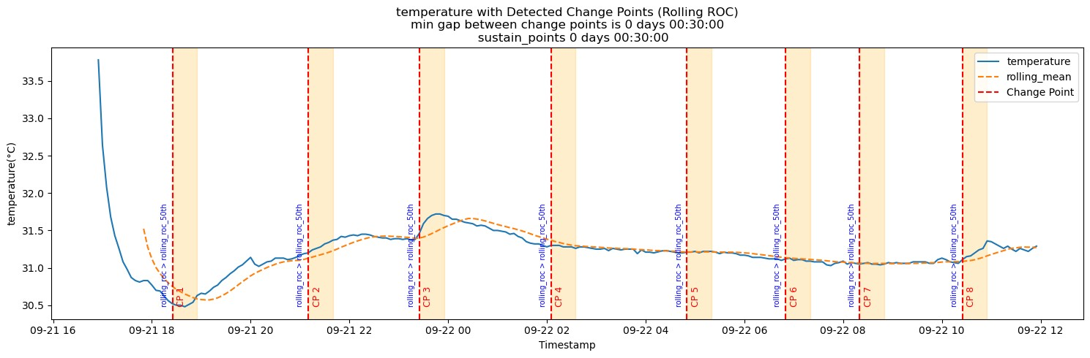
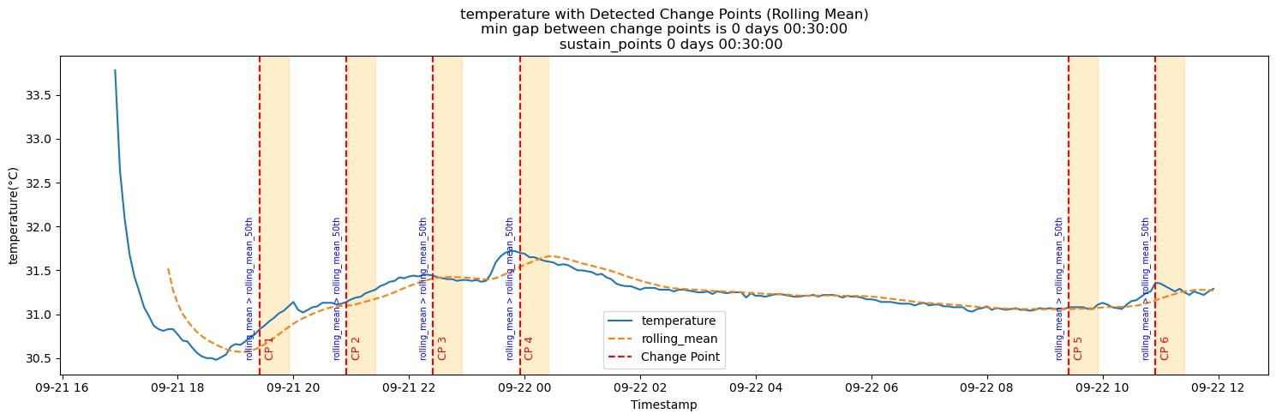
1b) Hydrogen Sulfide Initial Change Point Detection
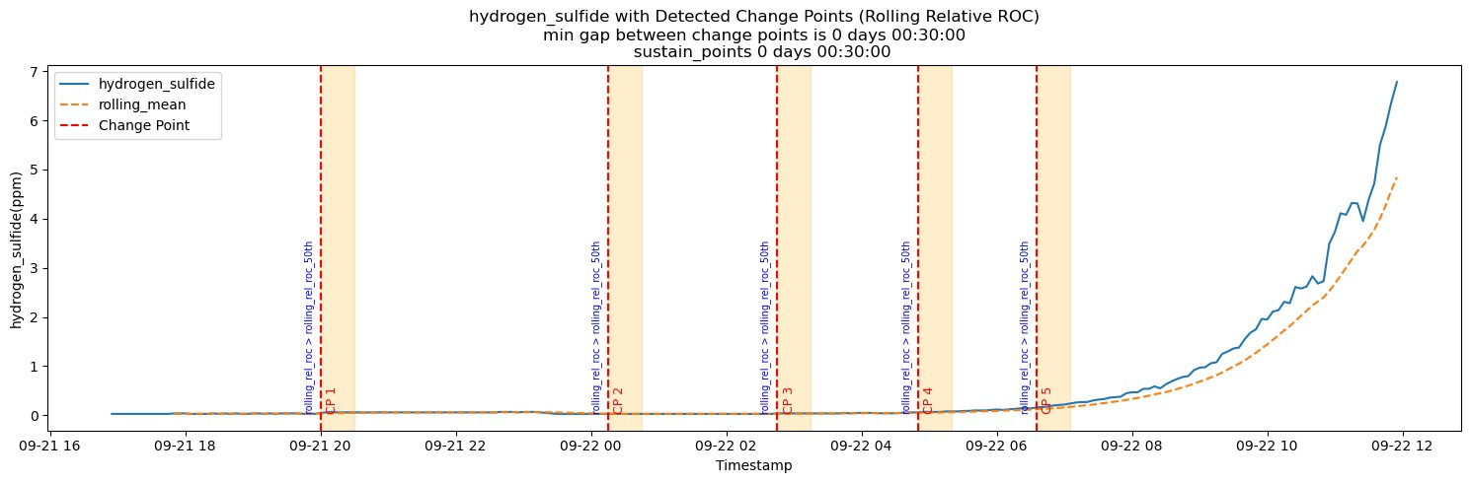
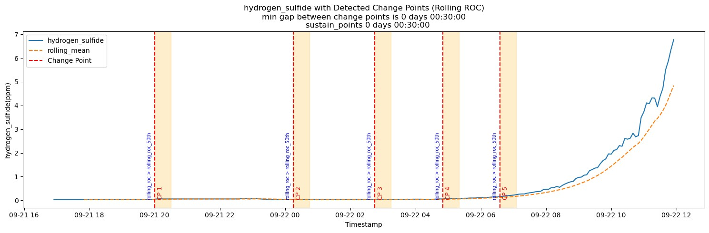
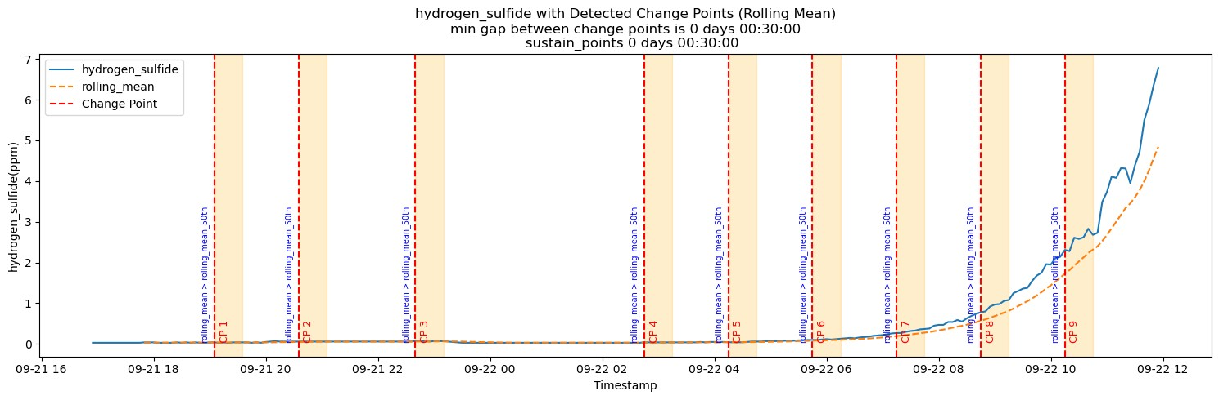
2a) Temperature Multi-Statistic Consensus Filtering
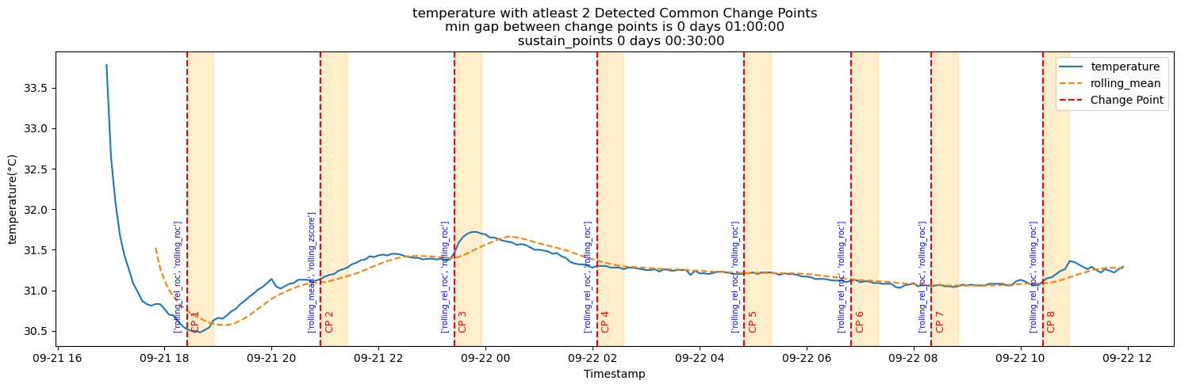
2b) Hydrogen Sulfide Multi-Statistic Consensus Filtering
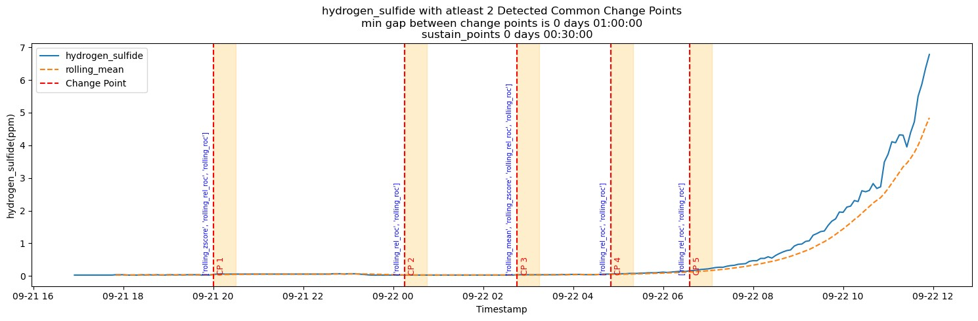
- Multi-Sensor Fusion - Final Change Points
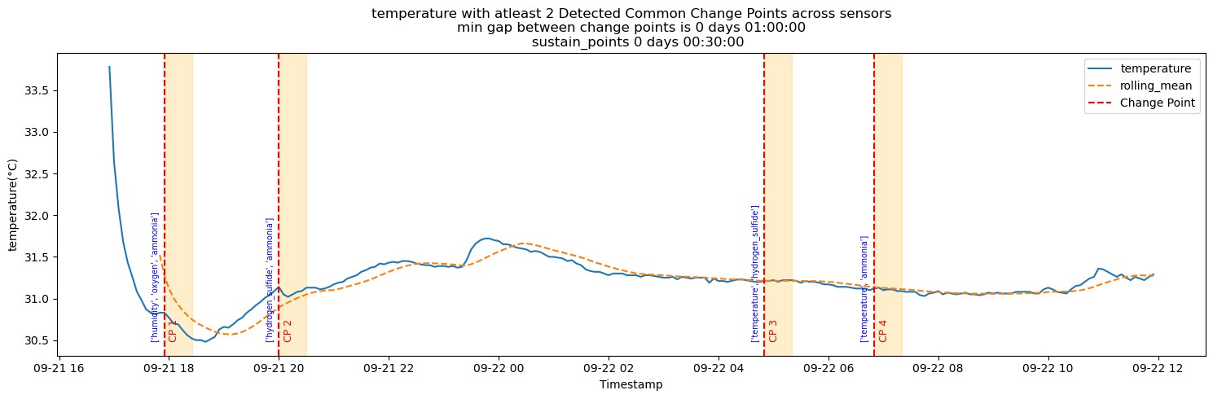
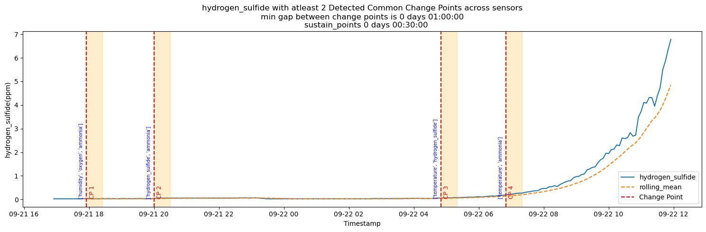
- Model Based Confirmation Layer - Critical Change Points
Seer
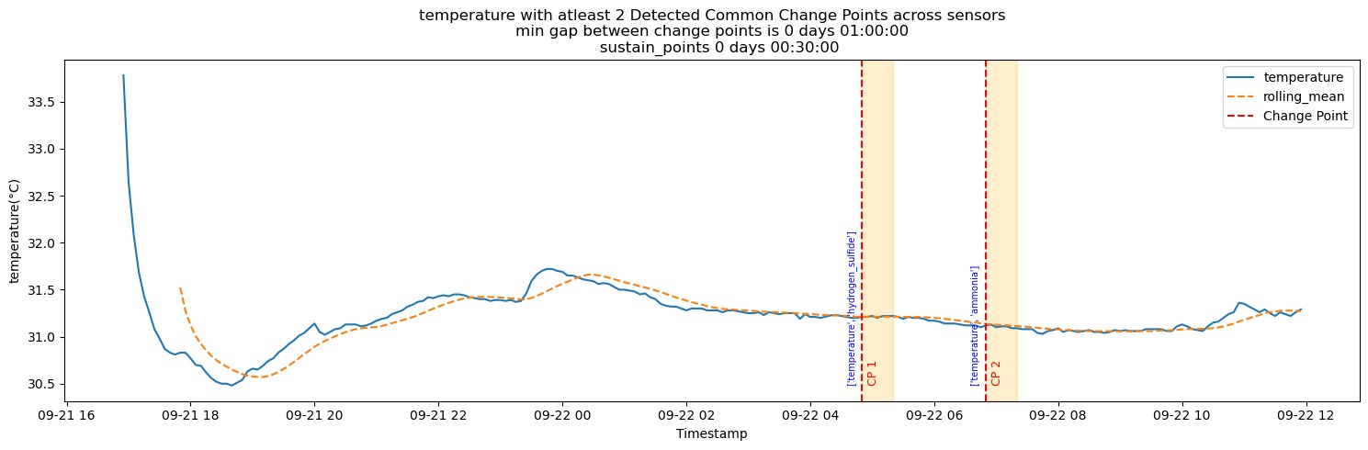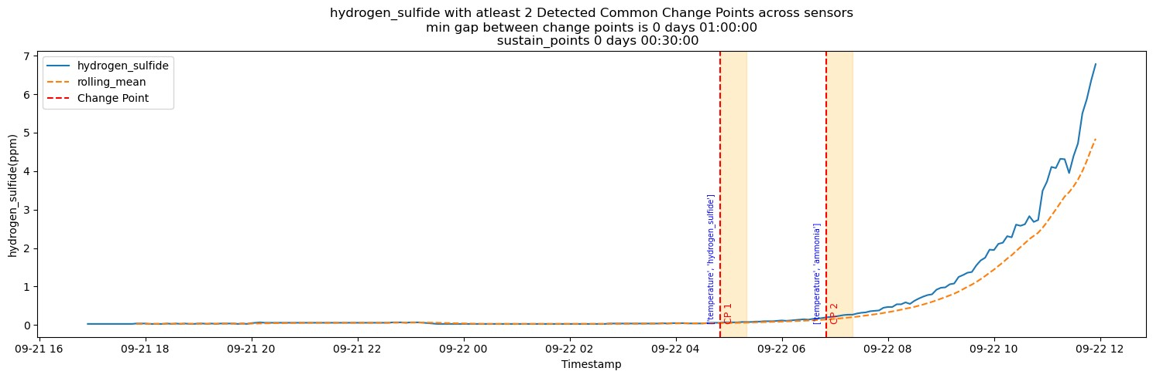
Tuna
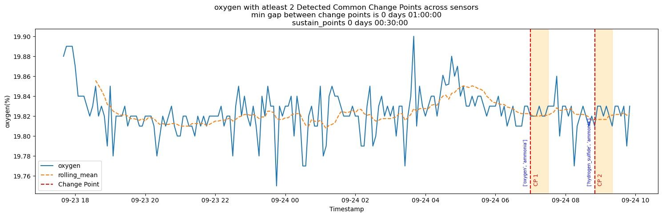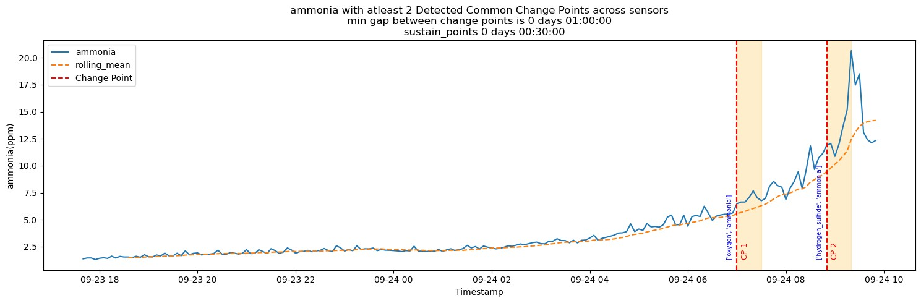
ML Models - Seer
1a) Spoilage Index Labeling
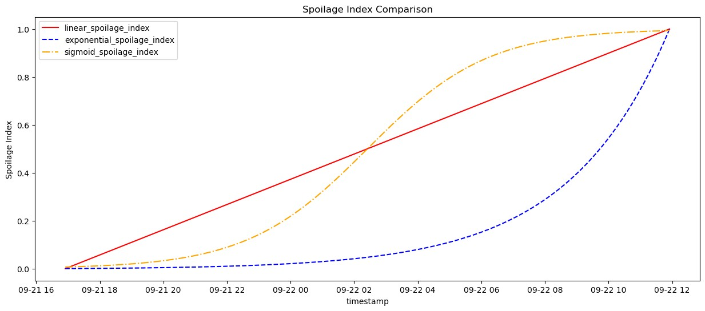
1b) Spoilage Index Predictions
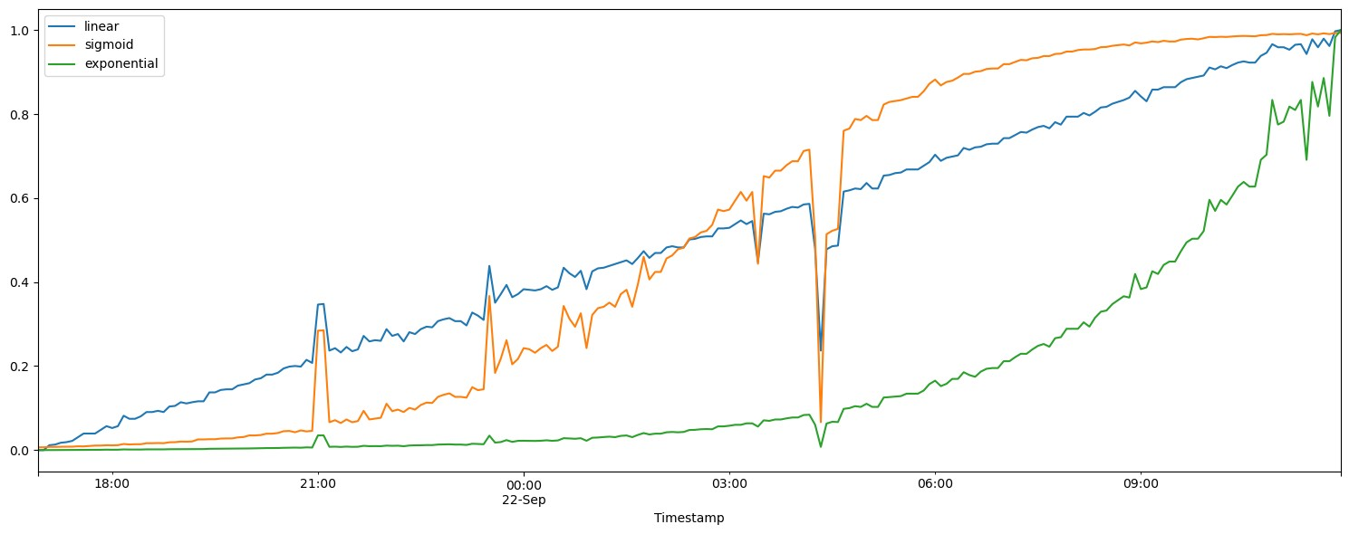
2) Spoilage Level Predictions
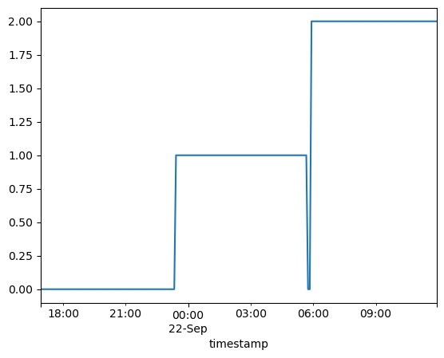
ML Models - Tuna
1a) Spoilage Index Labeling
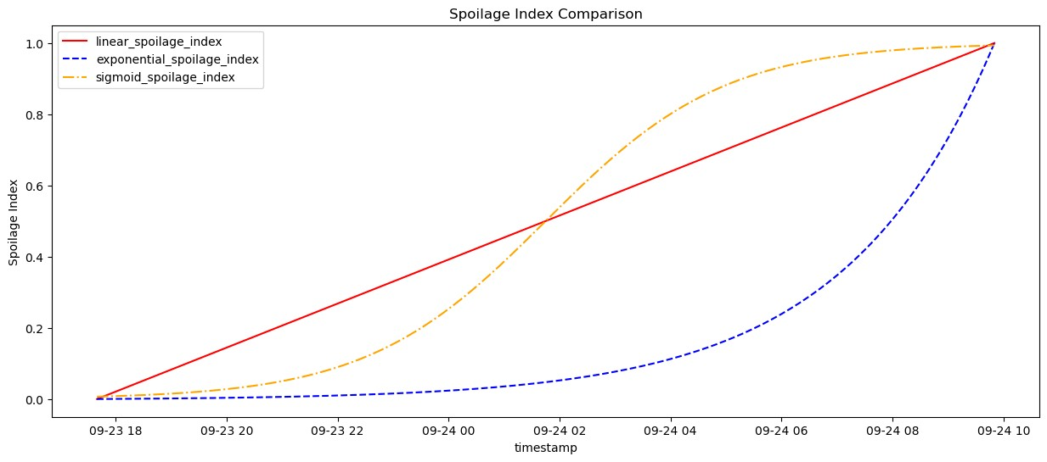
1b) Spoilage Index Predictions
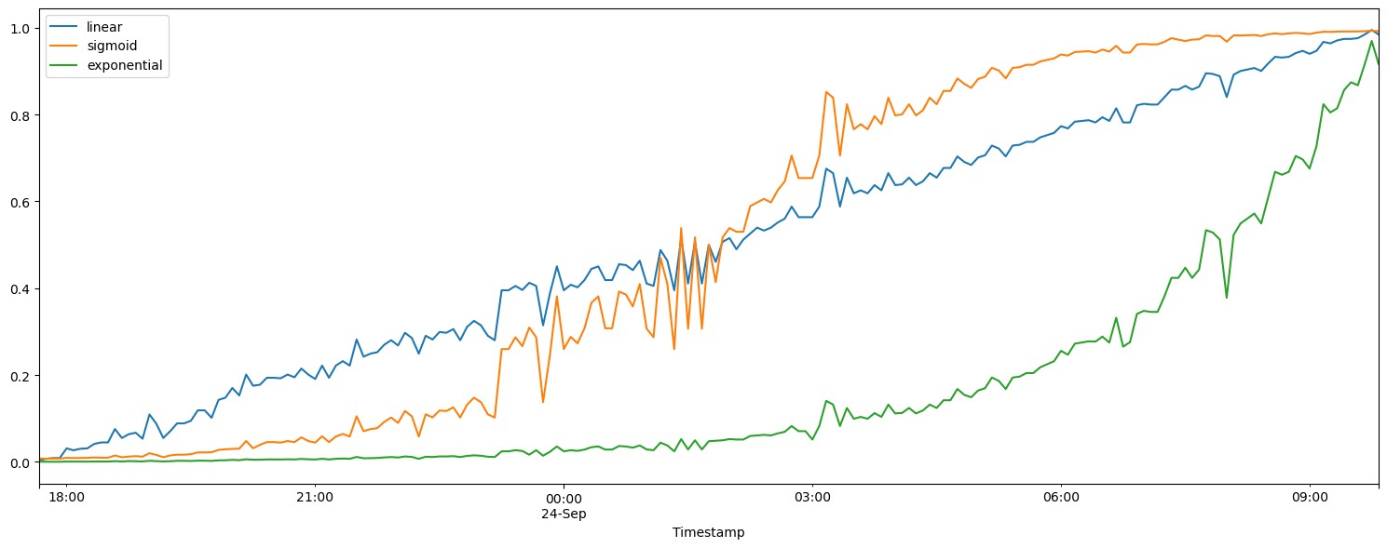
2) Spoilage Level Predictions
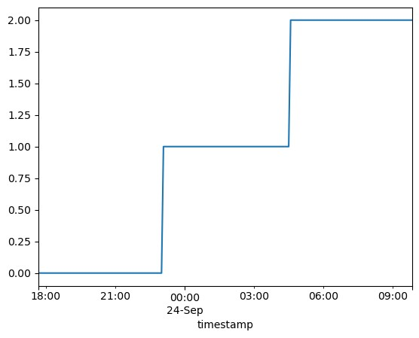

Insights & Key Learnings
- Consensus is king: Requiring ≥2 statistics (per sensor) and ≥2 sensors (system-level) dramatically reduces false positives.

- Dynamic thresholds win: Rolling medians and IQR of calculated statistics adapt to drift and seasonality better than static thresholds.

- Model gating matters: Spoilage index/level predictions filter “early but likely benign” bumps, yielding actionable alerts.

- H₂S & NH₃ behave exponentially: This validates the exponential label for regression and the emphasis on these sensors for CPs.

- Real-time nuance: Only apply the 1-hour separation after finalization to avoid suppressing valid detections.

- The system successfully balances sensitivity (catching spoilage early) and specificity (avoiding false triggers).

Results
- Before model gating: Multiple early CPs (especially from ROC/rROC) → useful but noisy.

- After model gating: Early, low-impact CPs dropped; fewer, more credible alerts remained.

- Alignment: Final CPs on forecasted data matched or slightly preceded CPs on actuals—supporting early warning value.

Findings
- Early spoilage was detected several hours before visible signs in most test cases.

- The hybrid approach reduced false positives by ~40% compared to single-metric detection.

- Model integration further improved confidence and interpretability of alerts.

- The system reliably triggered critical alerts 1–2 hours in advance, allowing intervention time.

- Achieved reliable spoilage index predictions in the range 0–1 aligned with expected spoilage trends.

- Classification models correctly separated spoilage into 3 freshness levels with good accuracy (within the assumptions of synthetic labels).

Business & Real-World Impact
- Waste Reduction: Early detection allows removal of spoiled lots before contamination spreads.

- Supply Chain Efficiency: Enables rerouting or early sales decisions to minimize loss by dynamic shelf-life estimation.

- Food Safety: Prevents spoiled fish from reaching consumers.

- Scalability: Online-compatible, species-agnostic core; thresholds and models can be adapted per species or site.

- Cost Savings: Reduced losses and extended shelf life translate to significant financial benefits.

Limitations
- Synthetic labels: Until true spoilage ground truth is collected, regression/classification is anchored to biologically reasonable surrogates.

- Site dependence: Baselines may vary by storage, season, handling.

Future Improvements
- Forecasting Models for sensor data to predict spoilage trends ahead of time.
- Integration with IoT systems for fully automated real-time alerts.
- Online Real-Time Deployment by extending a system for live sensor data streams.
- Larger dataset validation with real-world spoilage ground truth.
- Adaptive thresholds personalized for different fish types, storage conditions, and environments.

Conclusion
By combining dynamic rolling statistics, multi-level consensus, and a model-based confirmation layer trained on synthetic yet biologically-informed labels, this system provides early, reliable, and interpretable alerts for fish degradation of Seer & Tuna. It is robust to missing data, practical for real-time use, and designed for continuous improvement as richer labels become available. The framework is flexible, extendable, and capable of being deployed in real-time supply chain monitoring systems, offering both scientific insights and tangible business impact. The Early Fish Degradation Trigger Alert System represents a significant step toward smarter cold-chain monitoring, ensuring fresher products for consumers and reducing losses for businesses.

Appendix A: Glossary
- Rolling mean/median: Average/median computed over the last hour, shifting each minute.

- Rolling Z-score: How many standard deviations the current value is from its 1-hour average.

- ROC (rate of change): The step change vs. a previous point (e.g., 30 minutes ago).

- Relative ROC: ROC divided by the earlier value (i.e., percentage change).

- IQR (interquartile range): Spread between the 75th and 25th percentiles; robust to outliers.

- CP (change point): A time when the pattern meaningfully shifts.

- Spoilage index (0–1): A continuous score estimating where we are on the fresh→spoiled spectrum.

- Spoilage level (0/1/2): Fresh, Medium, Spoiled—simple operational categories.

Appendix B: Practical Settings (Defaults)
- Rolling window: 1 hour

- Candidate CP rule: > rolling median for ≥ 30 minutes

- Per-sensor consensus: ≥ 2 statistics (often ROC & rROC)

- Multi-sensor fusion: ≥ 2 sensors simultaneously

- Real-time separation: 1 hour applied only after final CP

- Model gating thresholds: Linear ≥ 0.3, Sigmoid ≥ 0.3, Exponential ≥ 0.1, Level ≥ 1

